
ASSIGNMENT 7: SAMPLE DATA INSERTION
DATABASE MANAGEMENT SYSTEM
ALLIANCE UNIVERSITY
Department of Computer Applications
SUBMITTED BY: RUPESH RL
REGISTER NO: 2511021240035
COURSE: BCA
YEAR: 2ND YEAR
PROJECT NAME: Courier and Parcel Delivery Management System

1. Aim
To insert realistic sample data into all ten tables of the courier database so that it looks like a real courier company, and to make sure the data follows the constraints and relationships.

2. Sample Data Plan
I made the data like a courier company working in South and West India in September and October 2026. There are 6 branches (Bengaluru, Mysuru, Chennai, Hyderabad, Mumbai and Kochi), 14 employees, 8 vehicles, 12 customers, 16 receivers and 25 parcels. The parcels are in different conditions: delivered on time, delivered late, delivered after a second attempt, returned, out for delivery, in transit and just booked. Every parcel has tracking rows and a payment, and some have complaints.
Things I kept in mind while making the data:
- Parent tables are filled first, because a foreign key value must already exist in the parent table. The order is Customer, Branch, Receiver, Employee, Vehicle, Parcel, Delivery_Assignment, Parcel_Tracking, Payment, Complaint.
- A parcel is given to an employee and a vehicle of its destination branch, because that branch makes the final delivery.
- Parcel 15 had a second delivery attempt, so it has two Delivery_Assignment rows. The first row has no actual delivery date because the receiver was not available.
- Payment amounts depend on the weight and type of the parcel. Pending and failed payments have no payment date.
- Dates are in the right order. The assigned date is not before the booking date, and the delivery date is not before the assigned date.

3. INSERT Statements

3.1 Customer: 12 customers who book parcels

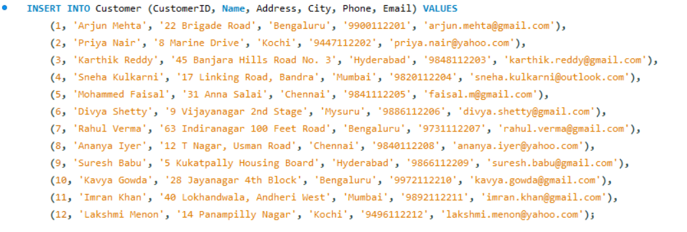

3.2 Branch: 6 branches

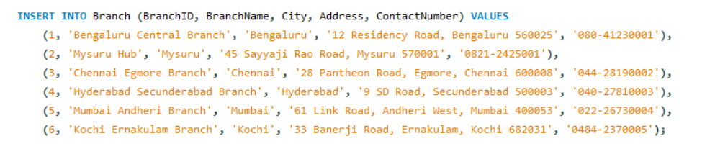

3.3 Receiver: 16 receivers

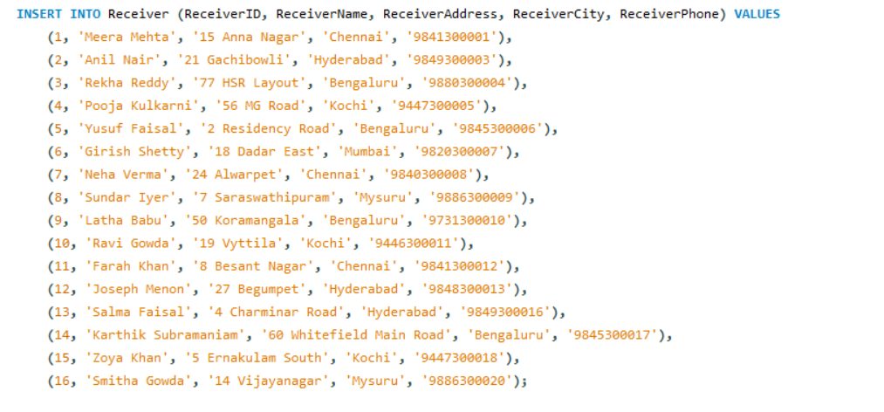

3.4 Employee: 14 employees

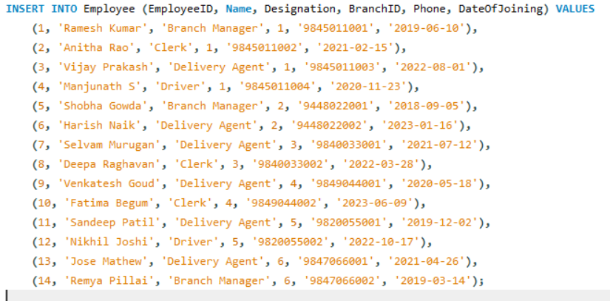

3.5 Vehicle: 8 vehicles

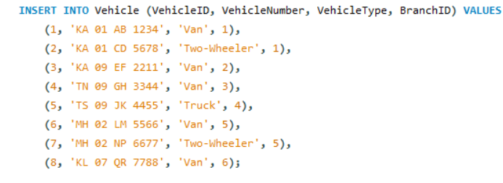

3.6 Parcel: 25 parcels

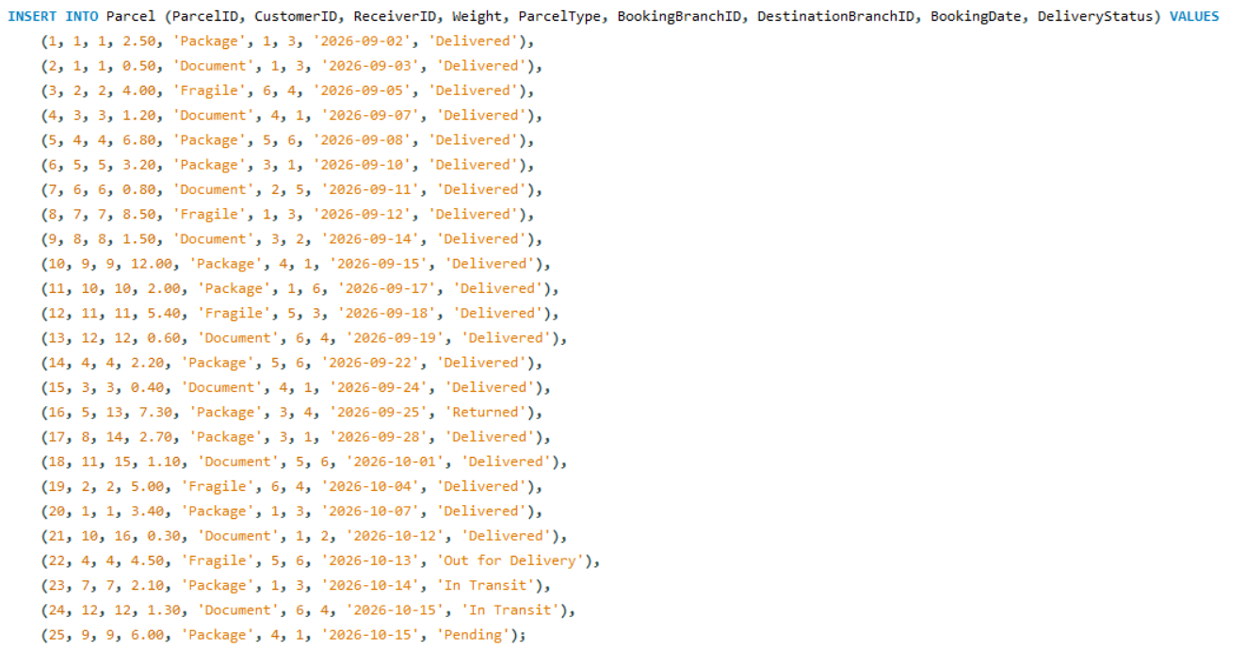

3.7 Delivery_Assignment: 23 assignments (parcel 15 has two)

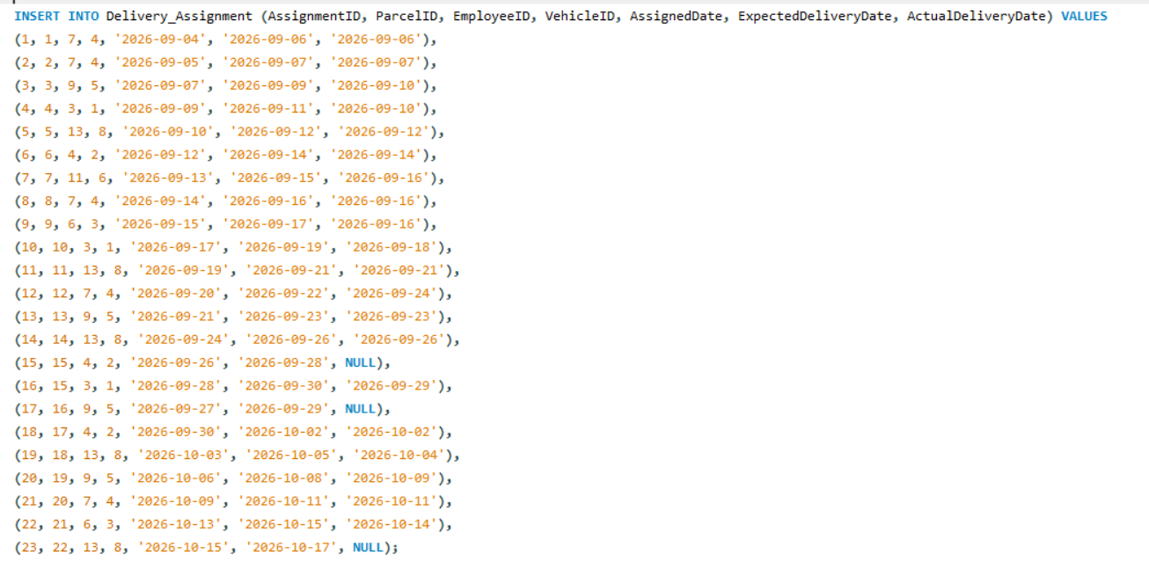

3.8 Parcel_Tracking: 74 tracking updates

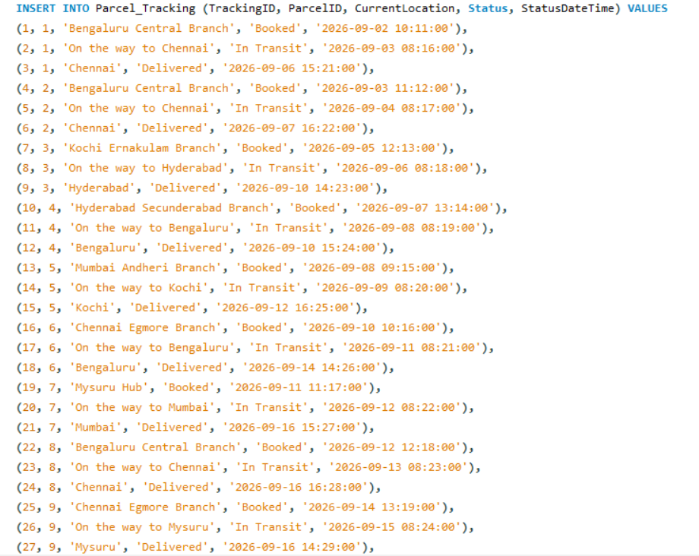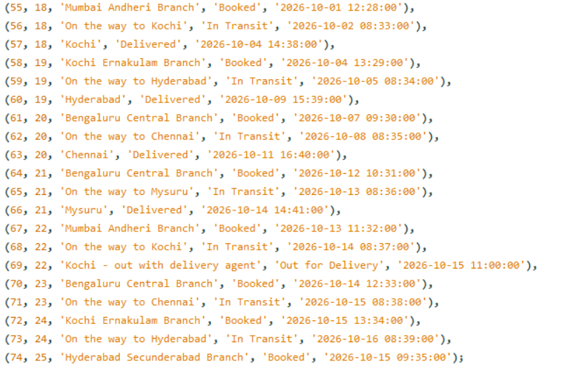

3.9 Payment: 25 payments, one for each parcel

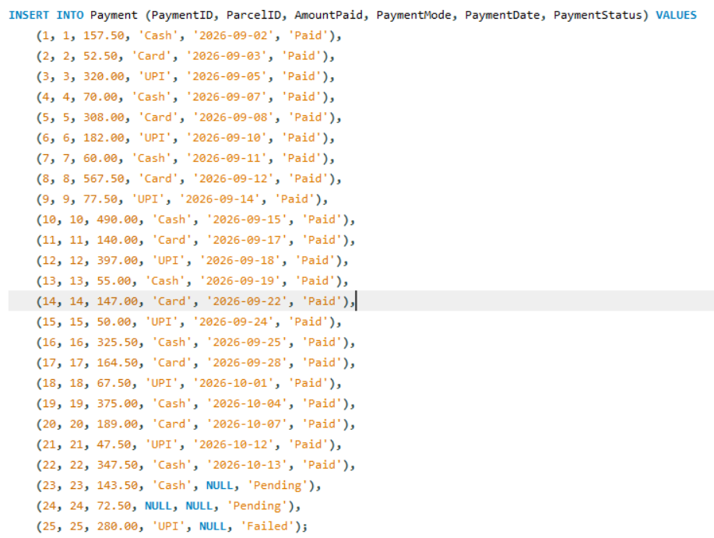

3.10 Complaint: 8 complaints

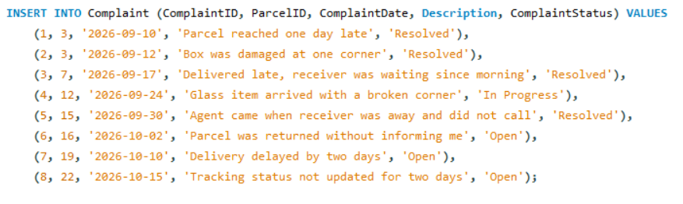

4. Checking the Data

4.1 Number of rows in each table

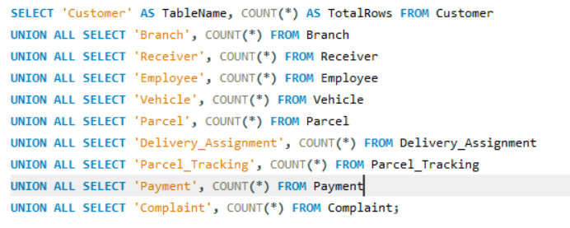
Output:
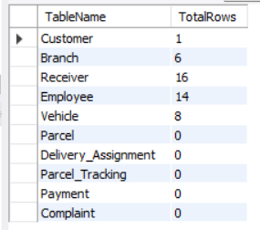
There are 211 rows in total in the ten tables. All the INSERT statements ran without any constraint error.

4.2 A look at the data
Output:
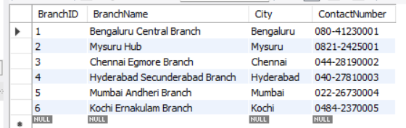
SELECT CustomerID, Name, City, Phone FROM Customer;
Output:
CustomerID | Name | City | Phone
1 | Arjun Mehta | Bengaluru | 9900112201
2 | Priya Nair | Kochi | 9447112202
3 | Karthik Reddy | Hyderabad | 9848112203
4 | Sneha Kulkarni | Mumbai | 9820112204
5 | Mohammed Faisal | Chennai | 9841112205
6 | Divya Shetty | Mysuru | 9886112206
7 | Rahul Verma | Bengaluru | 9731112207
8 | Ananya Iyer | Chennai | 9840112208
9 | Suresh Babu | Hyderabad | 9866112209
10 | Kavya Gowda | Bengaluru | 9972112210
11 | Imran Khan | Mumbai | 9892112211
12 | Lakshmi Menon | Kochi | 9496112212

SELECT * FROM Parcel;
Output:
ParcelID | CustomerID | ReceiverID | Weight | ParcelType | BookingBranchID | DestinationBranchID | BookingDate | DeliveryStatus
1 | 1 | 1 | 2.50 | Package | 1 | 3 | 2026-09-02 | Delivered
2 | 1 | 1 | 0.50 | Document | 1 | 3 | 2026-09-03 | Delivered
3 | 2 | 2 | 4.00 | Fragile | 6 | 4 | 2026-09-05 | Delivered
4 | 3 | 3 | 1.20 | Document | 4 | 1 | 2026-09-07 | Delivered
5 | 4 | 4 | 6.80 | Package | 5 | 6 | 2026-09-08 | Delivered
6 | 5 | 5 | 3.20 | Package | 3 | 1 | 2026-09-10 | Delivered
7 | 6 | 6 | 0.80 | Document | 2 | 5 | 2026-09-11 | Delivered
8 | 7 | 7 | 8.50 | Fragile | 1 | 3 | 2026-09-12 | Delivered
9 | 8 | 8 | 1.50 | Document | 3 | 2 | 2026-09-14 | Delivered
10 | 9 | 9 | 12.00 | Package | 4 | 1 | 2026-09-15 | Delivered
11 | 10 | 10 | 2.00 | Package | 1 | 6 | 2026-09-17 | Delivered
12 | 11 | 11 | 5.40 | Fragile | 5 | 3 | 2026-09-18 | Delivered
13 | 12 | 12 | 0.60 | Document | 6 | 4 | 2026-09-19 | Delivered
14 | 4 | 4 | 2.20 | Package | 5 | 6 | 2026-09-22 | Delivered
15 | 3 | 3 | 0.40 | Document | 4 | 1 | 2026-09-24 | Delivered
16 | 5 | 13 | 7.30 | Package | 3 | 4 | 2026-09-25 | Returned
17 | 8 | 14 | 2.70 | Package | 3 | 1 | 2026-09-28 | Delivered
18 | 11 | 15 | 1.10 | Document | 5 | 6 | 2026-10-01 | Delivered
19 | 2 | 2 | 5.00 | Fragile | 6 | 4 | 2026-10-04 | Delivered
20 | 1 | 1 | 3.40 | Package | 1 | 3 | 2026-10-07 | Delivered
21 | 10 | 16 | 0.30 | Document | 1 | 2 | 2026-10-12 | Delivered
22 | 4 | 4 | 4.50 | Fragile | 5 | 6 | 2026-10-13 | Out for Delivery
23 | 7 | 7 | 2.10 | Package | 1 | 3 | 2026-10-14 | In Transit
24 | 12 | 12 | 1.30 | Document | 6 | 4 | 2026-10-15 | In Transit
25 | 9 | 9 | 6.00 | Package | 4 | 1 | 2026-10-15 | Pending

4.3 Parcels in each delivery status
SELECT DeliveryStatus, COUNT(*) AS Parcels FROM Parcel GROUP BY DeliveryStatus ORDER BY Parcels DESC, DeliveryStatus;
Output:
DeliveryStatus | Parcels
Delivered | 20
In Transit | 2
Out for Delivery | 1
Pending | 1
Returned | 1

5. Checking Relationships (No Orphan Records)
An orphan row is a child row whose parent does not exist. The foreign keys already stop this, but I also checked with queries. Each count must be 0.
SELECT
(SELECT COUNT(*) FROM Parcel p LEFT JOIN Customer c ON c.CustomerID = p.CustomerID WHERE c.CustomerID IS NULL) AS ParcelNoCustomer,
(SELECT COUNT(*) FROM Parcel p LEFT JOIN Receiver r ON r.ReceiverID = p.ReceiverID WHERE r.ReceiverID IS NULL) AS ParcelNoReceiver,
(SELECT COUNT(*) FROM Delivery_Assignment d LEFT JOIN Parcel p ON p.ParcelID = d.ParcelID WHERE p.ParcelID IS NULL) AS AssignNoParcel,
(SELECT COUNT(*) FROM Parcel_Tracking t LEFT JOIN Parcel p ON p.ParcelID = t.ParcelID WHERE p.ParcelID IS NULL) AS TrackNoParcel,
(SELECT COUNT(*) FROM Payment y LEFT JOIN Parcel p ON p.ParcelID = y.ParcelID WHERE p.ParcelID IS NULL) AS PayNoParcel,
(SELECT COUNT(*) FROM Complaint m LEFT JOIN Parcel p ON p.ParcelID = m.ParcelID WHERE p.ParcelID IS NULL) AS ComplaintNoParcel;
Output:
ParcelNoCustomer | ParcelNoReceiver | AssignNoParcel | TrackNoParcel | PayNoParcel | ComplaintNoParcel
0 | 0 | 0 | 0 | 0 | 0

6. Checking Business Rules
These are the two checks I promised in Assignment 3 for rules that constraints do not cover. Both must return an empty result.
-- employee or vehicle that does not belong to the destination branch of the parcel
SELECT da.AssignmentID, da.ParcelID, e.BranchID AS EmpBranch, v.BranchID AS VehBranch, p.DestinationBranchID
FROM Delivery_Assignment da
JOIN Parcel p ON p.ParcelID = da.ParcelID
JOIN Employee e ON e.EmployeeID = da.EmployeeID
JOIN Vehicle v ON v.VehicleID = da.VehicleID
WHERE e.BranchID <> p.DestinationBranchID OR v.BranchID <> p.DestinationBranchID;
Output:
Empty set
-- parcels marked Delivered that have no assignment with an actual delivery date
SELECT p.ParcelID
FROM Parcel p
WHERE p.DeliveryStatus = 'Delivered'
AND NOT EXISTS (SELECT 1 FROM Delivery_Assignment da
WHERE da.ParcelID = p.ParcelID AND da.ActualDeliveryDate IS NOT NULL);
Output:
Empty set

7. Result
Sample data was inserted in all ten tables, 211 rows in total, without any constraint error. The orphan checks and rule checks gave no problem.

8. Conclusion
The sample data covers the full life of a delivery: a normal delivery, a late delivery, a second attempt, a return, pending and failed payments, and complaints. This makes the database look like a real courier company, and I use the same data for the queries in Assignment 8 and Assignment 9.

